TEST 2 UNIT 4,5,6

I. Look and write the numbers.

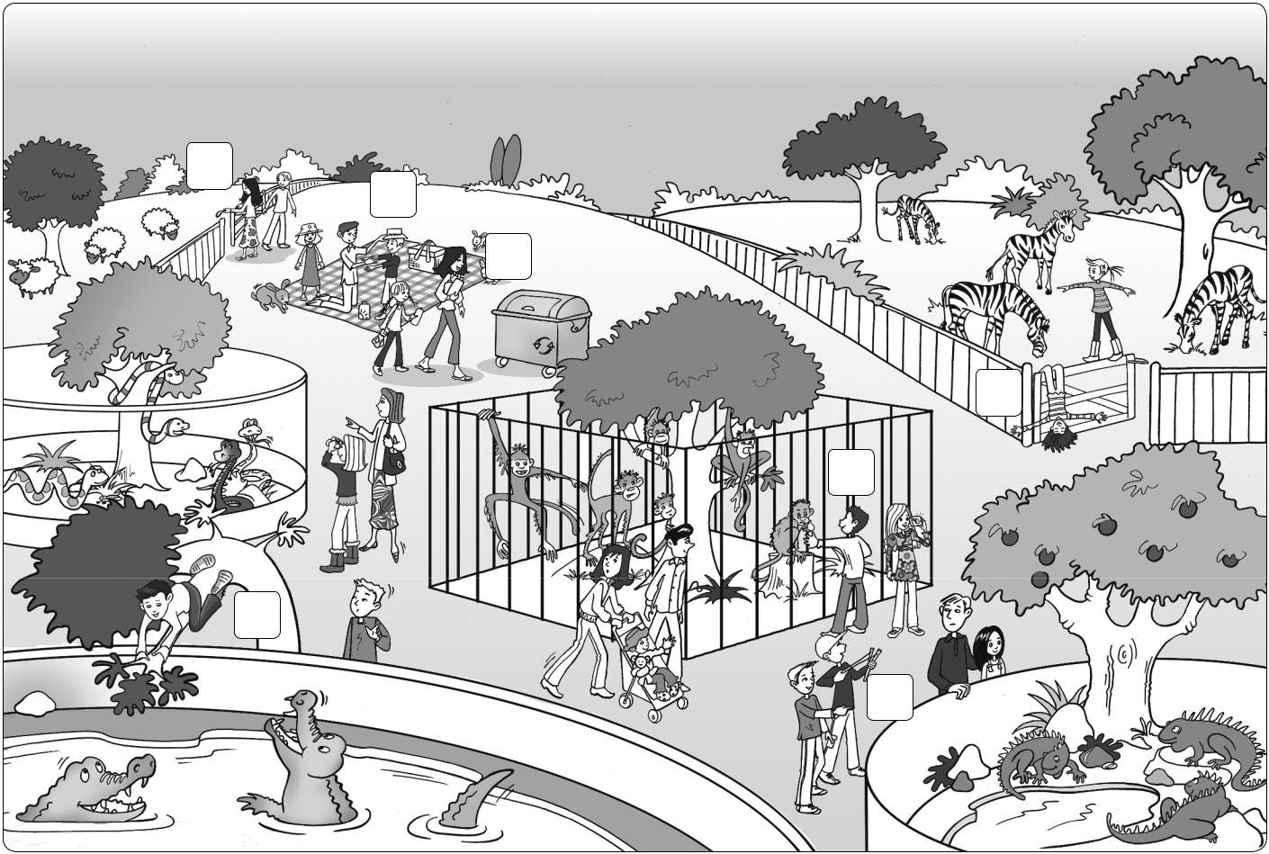

1
2
3

4
6

5

7

He’s climbing a tree. | 5 | He’s throwing stones at the tree.
They’re playing on the gate. |  | He’s touching the animals.
They’re putting on sunscreen. |  | She’s putting the litter in the garbage can.
They’re shutting the gate.

Sunscreen: kem chống nắng
Throw stone: ném đá
Shut the gate: đóng cổng
Touch the animals: chạm vào động vật

II. Complete the table.

Good | Bad
putting the litter in the garbage can

III. Match the beginnings and ends of the rules.
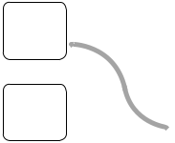

1 | Climbing trees is dangerous. | b | a | The animals can bite you.
2 | Put your litter in the garbage can. |  | b | You can fall and hurt yourself.
3 | Wear a sun hat! |  | c | You can break them or hurt yourself.
4 | Playing on gates is bad. |  | d | Animals can’t eat it.
5 | Hurting animals is not kind. |  | e | You can get sunburned.
6 | Shut the gate behind you. |  | f | The animals can get out.
7 | Touching the animals is dangerous. |  | g | They can get angry or scared.

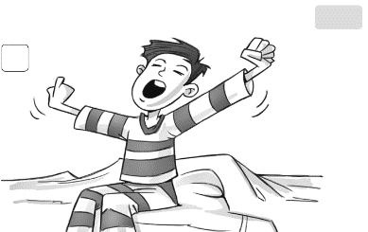
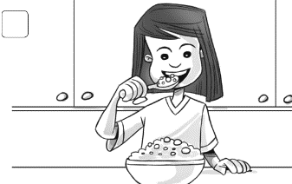
IV. Circle.

1 | 2

have breakfast / get dressed get up / brush my teeth
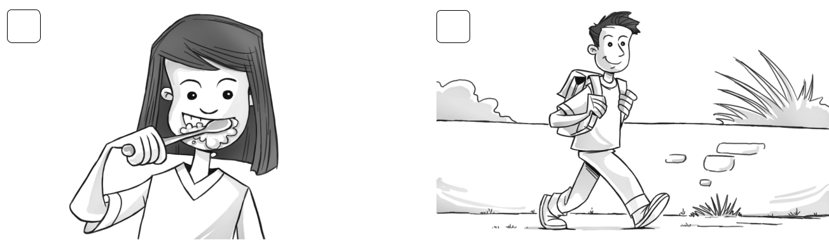

3 4

have a shower / brush my teeth |  |  |  |  | catch the bus / walk to school
V. Complete. |  | every day First |  |  | every day Finally Next
I get up at seven o’clock 1 every day . 2 |  |  |  |  |  | , I have a shower. Then I
get dressed. 3 |  |  |  | , I brush my hair and have breakfast. 4 |  |  |  |  | ,
I brush my teeth. Then I go to school. But I don’t go to school 5 |  |  |  |  |  |  |  |  | .
VI. Underline the correct words.
Tim | What time 1 do you / does you / you do get up on Saturdays?
Carl | I 2 get up / gets up / getting up at eight o’clock. But my brother Simon
 | 3 get up / getting up / gets up at nine o’clock. He’s very lazy.
Tim | 4 Doing / Does / Do your friends go to the park on Saturdays?
Carl | Yes, they 5 don’t / do / does. We 6 plays / playing / play soccer there. But my
 | sister 7 doesn’t / do / don’t come.
Tim | What 8 do / does / don’t she do?
Carl | My mom and my sister 9 does / do / don’t the food shopping.

