REVIEW 1 – UNIT 4-5-6
I. Look and write

1………………… 2………………… 3………………… 4………………… 5………………
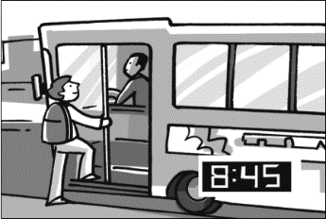
6………………… 7………………… 8………………… 9………………… 10………………

II. Ask and answer
1. What is he/she doing? 2. What are they doing?
She/ He is + Ving They are Ving
1. What is she doing?  ………………………………………. | 2 What is he doing?  ………………………………………
3……………………..?  He is brushing his teeth. | 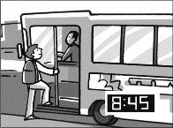  4………………………..?  He is catching the bus.
5. What are they doing?  ……………………………………. | 6. What are they doing?  ………………………………………
7…………………………?  They are walking to school. | 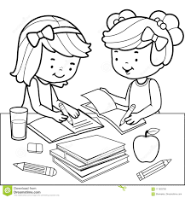8. ………………………?  They sre doing homework.

III. Read and underline the proper nouns, then answer questions

My name is Ellen. My favorite movie in the world is Born Free. It’s a movie about a lion in Kenya. A woman called Joy Adamson helps a lion to live free in Africa. My dream is to go to Africa one day and see the lions living free.

Answer questions
1. What is her name?
…………………………………………………………………………………………
2. What movie does she like?
…………………………………………………………………………………………
3. Does Joy Adamson help a lion to live free in Africa
…………………………………………………………………………………………
4. Where does she want to go?
…………………………………………………………………………………………

IV. Read and complete the sentences.

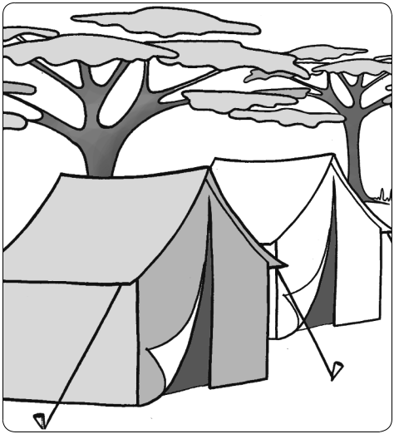

Ellen’s dream is 1 coming (come) true! She is 2……….(go) to Cattien national park to see Champa 3……………(live) in the wild. It’s so exciting, she says. I can’t wait to see real lions. Today, Ellen’s family are 4…... fly to Vienam, but they aren’t 5………………… (stop) in Dongnai.
They are 6 …………(get) on a bus and 7…………(drive) to Dongnai. Ellen is happy. Catien is a famous national park, she says. You can see lots of Champa there.

