Phuoc Vinh B Primary school
Full name:...............................................................class 5a....

REVIEW ( U1-6)
- Write the words ( viết từ)
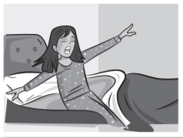  ______________ | ______________ | _______________ | _______________
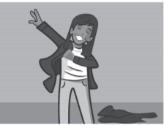  ______________ | 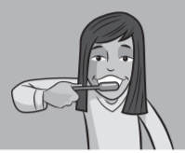  _______________ | 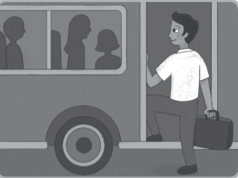  ______________ | _______________
_______________ | _______________ | _______________ | _______________
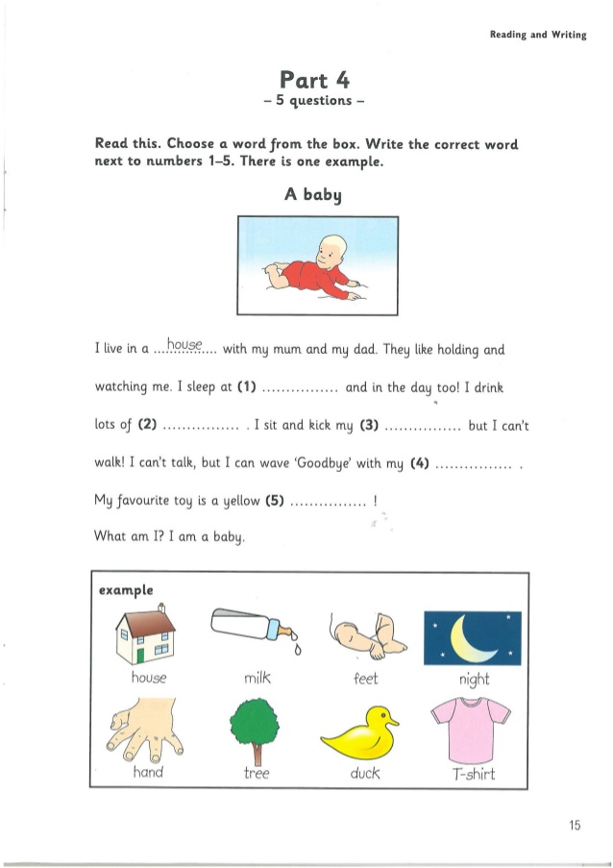
II.
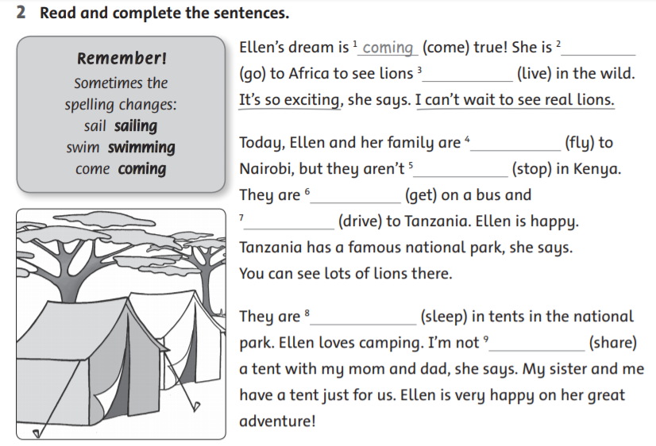
III.

IV. Order the words ( Sắp xếp các từ thành câu)
- bus / the / They / catch / don’t/./
______________________________________________________
- do / go / What / you / time / school / to /?/
______________________________________________________
- at / I / to / school / 6.30 / go /./
______________________________________________________
- he / live / Does/ in / house / big /a/?/
______________________________________________________
- is /a/ taking / Thao / photo/./
______________________________________________________
- monkey / I/ funny / am / watching / this/./
______________________________________________________

V. Answer the questions ( trả lời các câu hỏi)
1. Are you reading a book? _______________________________________
2. What are you doing? _______________________________________
3. What time do you get up? _______________________________________
4. can you open the window, please? _________________________________
5. Does he playing football? _________________________________

