Phuoc Vinh B Primary school.

Name:................................................................class 3a.....

**TEST 1**

**I. Circle the odd-one-out**.(Khoanh tròn từ khác loại).

1 A. socks B. shorts C. kitchen D. coat

2. A. sheep B. dress C. T-shirt D. pants

3. A. fish B. shoes C. lion D. goat

4. A. living room B. hat C. bedroom D. bathroom

5. A. house B. apartment C. chair D. dining room

6. A. chick B. tiger C. rabbit D. teacher

7. A. cousin B. upstairs C. grandma D. sister

8. A. downstairs B. zebra C. bird D. cat

9 . A. box B. yo-yo C. doll D. ball

10. A. umbrella B. queen C. frisbee D. pool

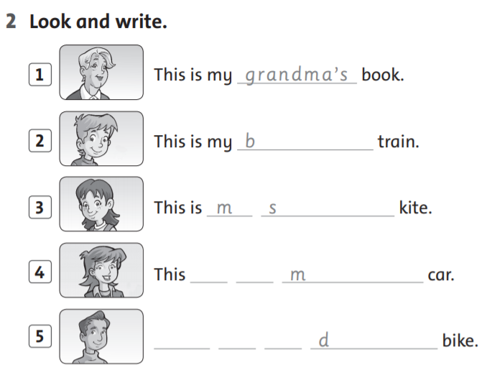

**II**

Where’s Where are He’s She’s They’re

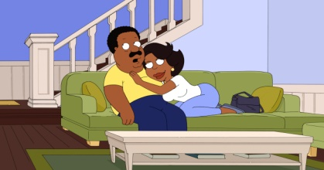**III. Look at the pictures and write. (Nhìn vào hình ảnh và viết.)**

_***Where are*** Mom and Dad ?

***They’re*** in the living room.

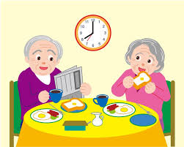 __________________ Grandma and Grandpa?

**2**

_________________ in the dining room.

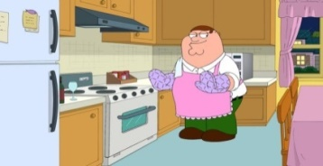

**3**

___________­­­­___ Dad? _____________ in the kitchen

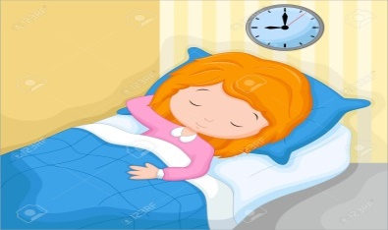

**4**

___________________ sister?

__________________ in the bedroom.

**IV: MATCHING (nối)**

T-shirt shorts bedroom hat shoes teacher

These are my

This is my

cousin mom fish coat books pants socks

**V. Answer the questions (trả lời câu hỏi)**

|  |  |
| --- | --- |
| 1. Kết quả hình ảnh cho is she in the bedroom?Where’s she?   _______________________  _______________________ | 1. Kết quả hình ảnh cho is she in the bedroom?Are they in the   living room?  ___________________ |
| 1. Kết quả hình ảnh cho is he in the kitchen?Where’s he?   ____________________  ____________________ | 1. Kết quả hình ảnh cho is she in the dining room?Is she in the dining room?   ____________________ |

Phuoc Vinh B Primary school.

Name:................................................................class 3a.....

**TEST 2**

1. **Write the words ( viết từ)**

|  |  |  |  |
| --- | --- | --- | --- |
| **_______________** | **_______________** | **_______________** | **_______________** |
| **_______________** | **_______________** | **__________________** | **__________** |

**II. Look at the picture. Read and answer the questions.**

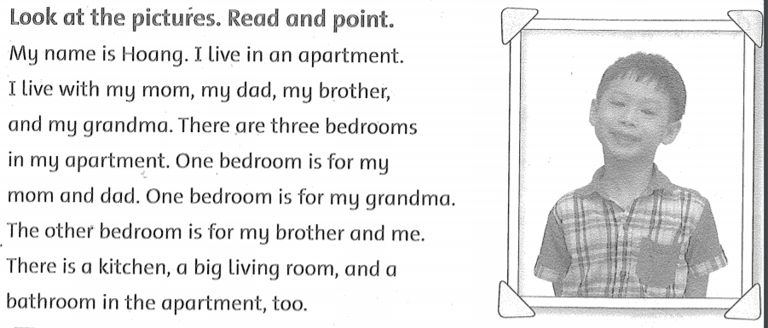

1. What’s his name?

_____________________________________________

1. Where does he live?

_____________________________________________

1. Who does he with?

_____________________________________________

1. How many bedrooms are there in his apartment?

_____________________________________________

1. Is there a big living room in the apartment?

_____________________________________________

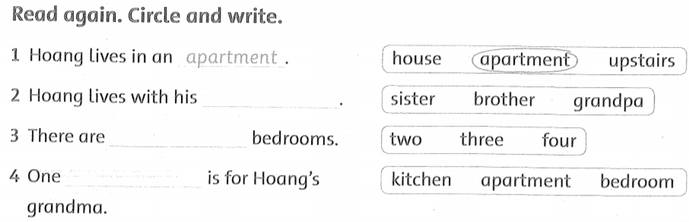

**III. Reorder ( SẮP XẾP)**

1. in / the / she / Is/ kitchen/?/

_________________________________________________

1. not / is / she / No, /./

_________________________________________________

1. are / Where / Dad / Tim / and /?/

_________________________________________________

1. the / They /living room / in / are /

_________________________________________________

1. Mom/ in / bedroom / and / the / Billy /Are /?/

_________________________________________________

1. they / No, / not / are /./

_________________________________________________

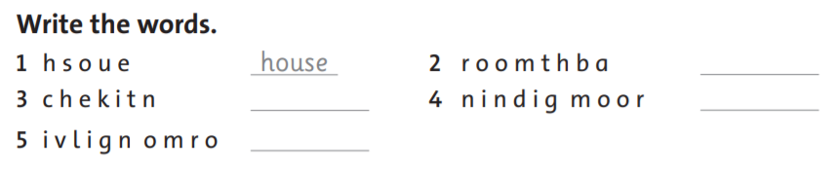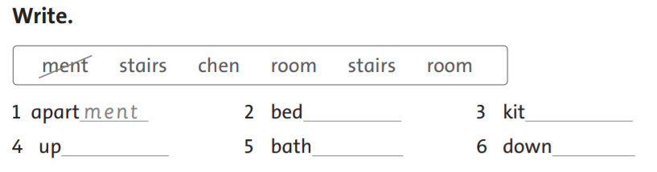

**V..**

**IV. Write**

***The end.***

Phuoc Vinh B Primary school.

Name:................................................................class 3a.....

**TEST 3**

**I. Complete the sentence ( hoàn thành các câu)**

1. This _ _ my school.
2. What’s _ _ _ _ name ?
3. How _ _ _ you ?
4. Hi, Tony. I _ _ Laura.
5. Nice to m _ et you.
6. Hi, _ _ _ is Peter.
7. Hi, _ _ name is Phong.
8. I am _ _ _ _, thank you.
9. My _ _ _ _ is Mary.
10. Nice _ _ meet you.

**II. Read and complete (hoàn thành các câu.**

**How What’s My Where’s Can Who**

1. ..................................... your name?
2. ..................................... name’s Peter.
3. ..................................... old are you?
4. .....................................the girl?
5. .............................you see her toy?
6. .......................is this?

**III. Choose correct answer ( Chọn câu trả lời đúng)**

1. How _________ you? A. am B. is C. are D. it

2. Good bye. ______ you later. A. What B. See C. How D. Are

3. __________. I am Lili. A. Hello B. Good-bye C. It D. You

4. Good bye. See you __________. A. later B. late C. How D. Are

5. ___________ your name? A. Hello B. Good-bye C. What D. What’s

6. What’s _____? It’s a notebook. A. he B. she C. that D. dog

7. What’s your name?

1. I’m fine, thanks B. My name’s Mai C. Thank you

8. How are you?

1. I’m fine, thanks B. yes, please. C. I’m nine years old

**IV. Match the sentences (nối)**

|  |  |  |
| --- | --- | --- |
| 1. ***Who’s that?*** | **1b** | 1. Yes, it is. |
| 1. How old are you? |  | 1. ***It’s Mr. Loc.*** |
| 1. Is that Mai? |  | 1. She’s eight years old. |
| 1. How old is Mai? |  | 1. I’m eight years old. |
| 1. Where’s the doll? |  | 1. No, she isn’t. |
| 1. Where are the bathrooms? |  | 1. It’s a chair. |
| 1. What’s this? |  | 1. It’s under the bed. |
| 1. Is she a doctor? |  | 1. They’re upstairs. |

**V. Circle the answer. (Khoanh tròn câu đúng)**

|  |  |
| --- | --- |
| 1. How are you?   1. I’m fine .Thank you. 2. I’m John. | * 1. What color is this?  1. It’s black. 2. It’s a bag. |
| * 1. What’s this?  1. Yes, it is. 2. It’s a pen. | * 1. Is this a book?  1. It’s a pen. 2. No, it is not. |

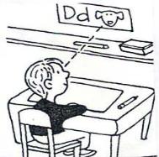

|  |  |
| --- | --- |
| 5. a. Sit down.  b. Look at the board. | 6. a. downstairs  b. upstairs |
| 7. a. Open your book.  b. Close your book. | 8. a. Stand up  b. Sit down |
| 9. a. Is this a book? Yes, it is.  b. Is this a pencil? Yes, it is. | 10. a. It’s a chair.  b. It’s a ruler. |