Phuoc Vinh B Primary school.
Name: _________________________________ Class: 4a_________
TEST 1
- Write the words ( viết từ)
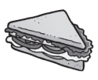  _________________ | _________________ | 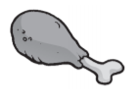  _________________ | 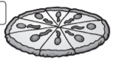  ________________
_________________ | _________________ | _________________ | ________________
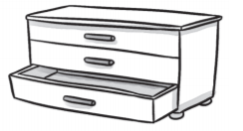  _________________ | _________________ | 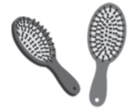  _________________ | 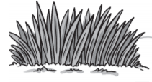  ________________
_________________ | _________________ | 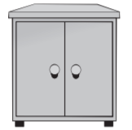  _________________ | 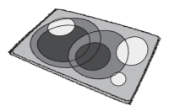  ________________

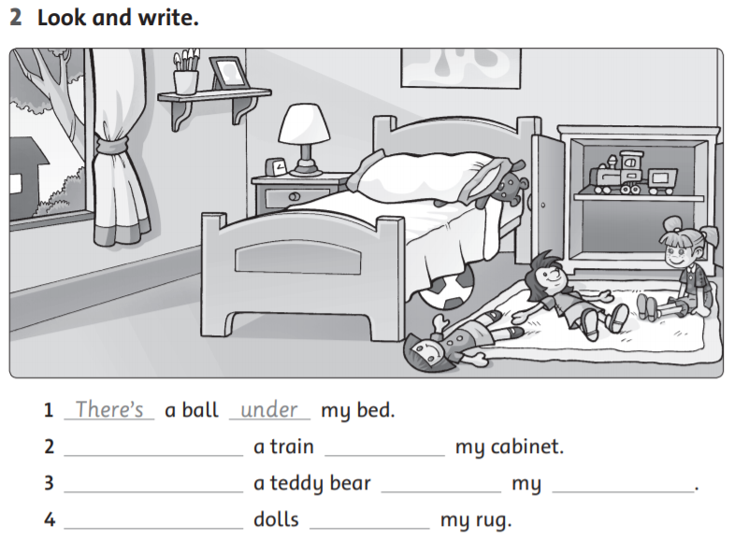
Nhìn tranh và viết

- Nhìn tranh và viết.
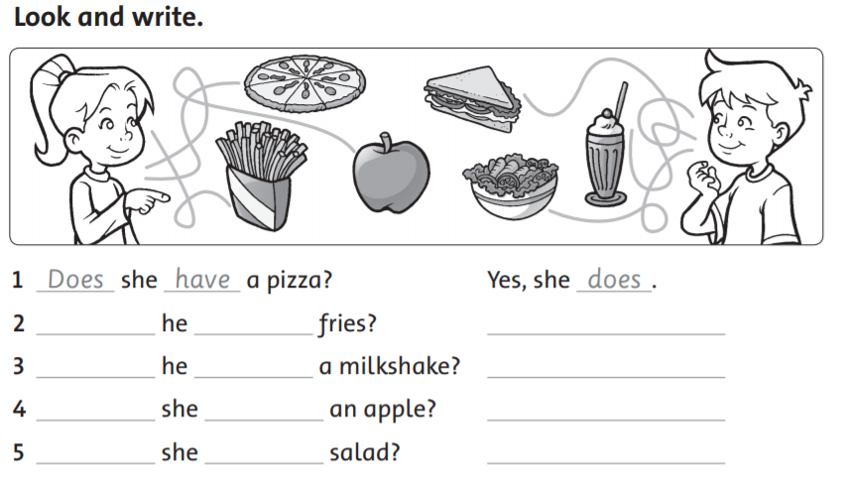
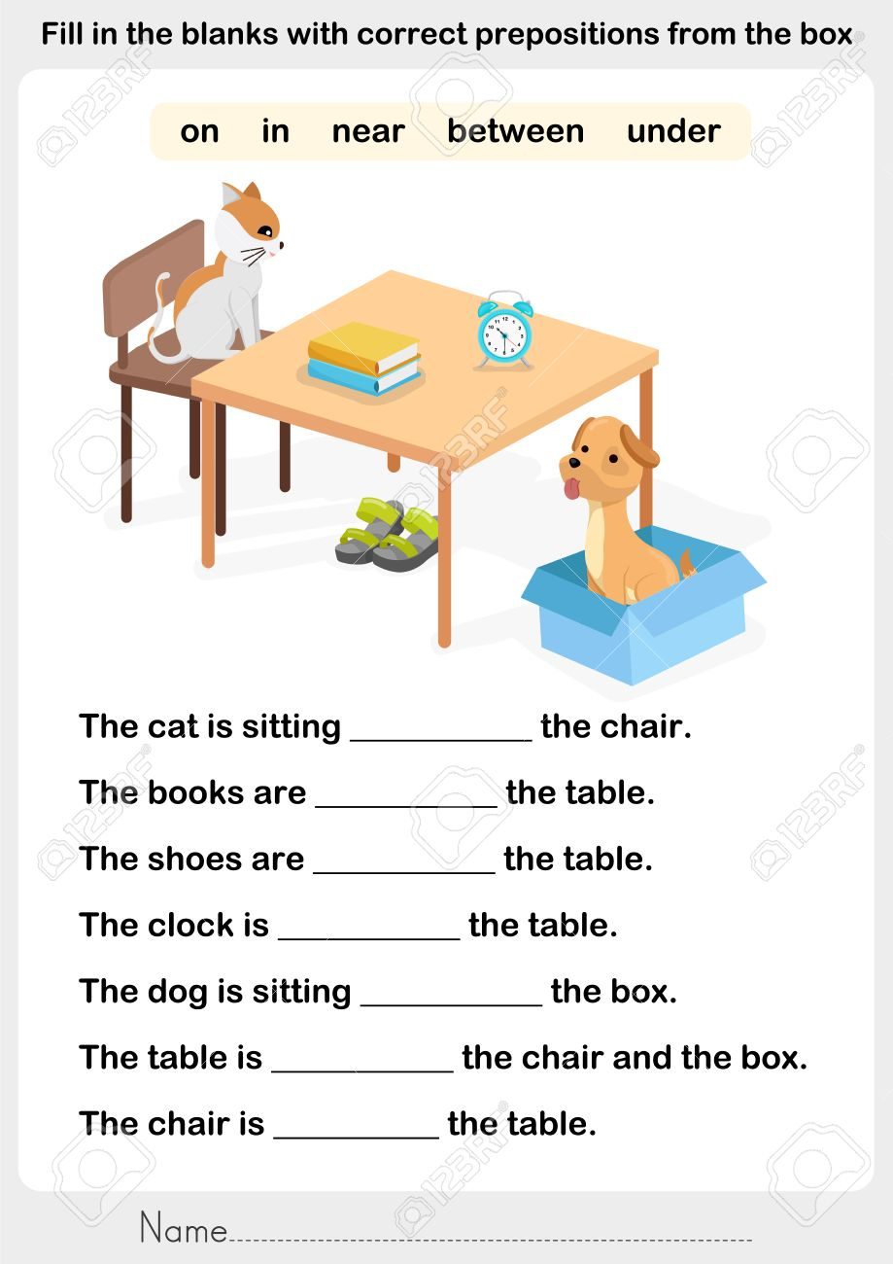
- Điền các giới từ vào chỗ trống ( chú ý: near: gần, between: ở giữa)

Phuoc Vinh B Primary school.
Name: _________________________________ Class: 4a_________
TEST 2
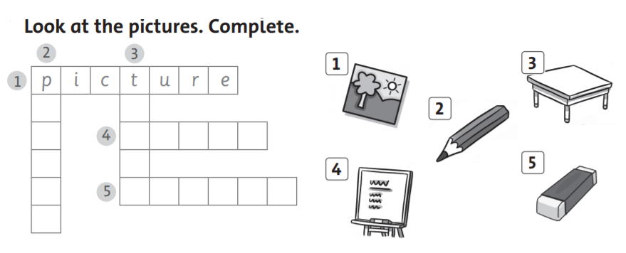
is are
I.
II. Complete. ( Điền is hoặc are vào chỗ trống)
1. This is my coat hook. | 2. Those ___________my pens.
3. These________ my notebooks. | 4 Those______ your hats.
5. This _________ my bed. | 6 These _________new bikes.

III. Complete the sentences with There is( There’s) or There are.
1. There’s a train under the bed. | 2.______________a doll under the bed.
3. _____________two coats in the cabinet. | 4. ______________one book on the shelf.
5. ______________cars in the cabinet. | 6. ______________five bats by the tree.
IV. REODER ( sắp xếp)
1. books / are / under / There / bed / the /. | →_____________________________________
2. is / Rosy’s / This / dad / not /. | →____________________________________
3. eyes / has / brown / He /. | →____________________________________
4. many / chairs / there / How / are /? | →____________________________________
5. lots / Ha / balls / in / of /his / has /bag /. | →____________________________________

V. Điền This hoặc That vào chỗ trống
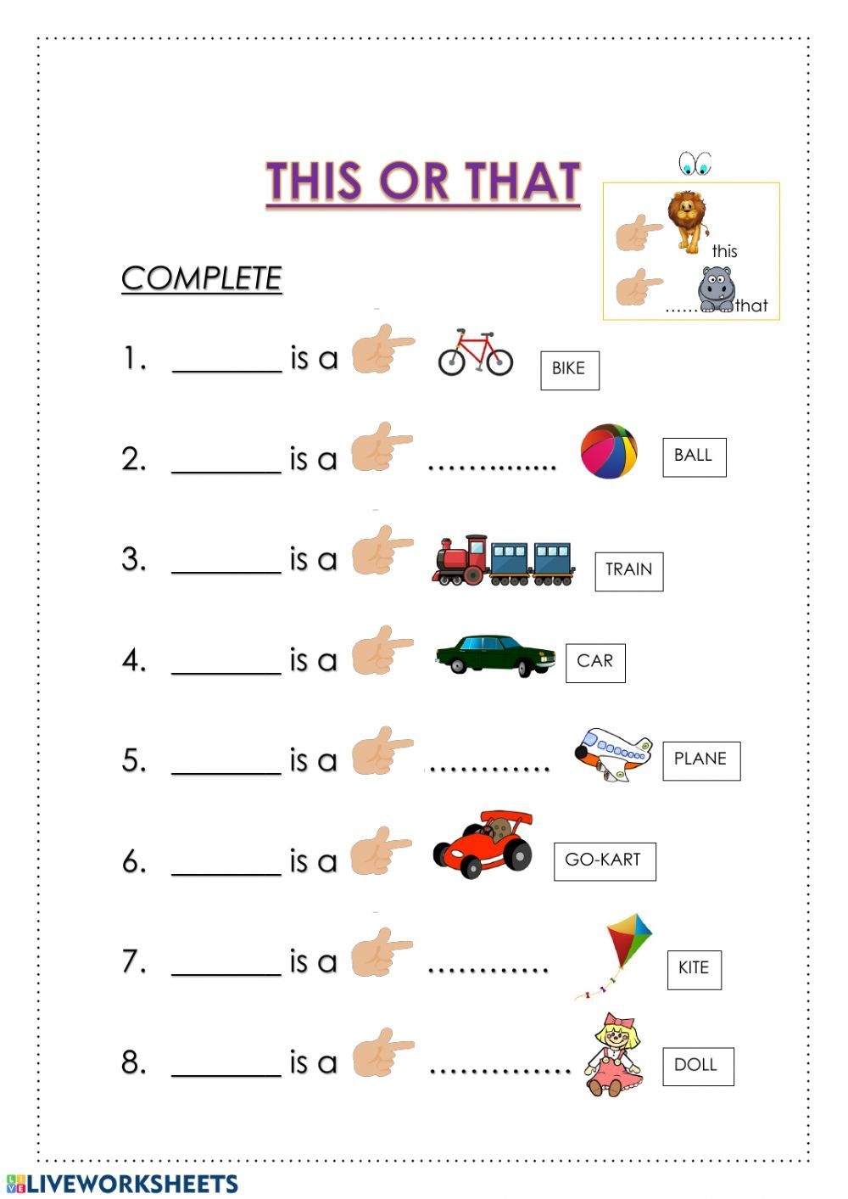
VI. Choose A, B,C or D.
- How ______________bikes are there?
A. weather | B. old | C. many | D. far
- There ____________one bike.
A. am | B. is | C. are | D. have
- Do you have a pizza?
A. Yes, I do. | B. No, I do. | C. No, she doesn’t. | D. Yes, I don’t.
- _____________she have a salad?
A. Do | B. Does | C. Is | D. What
- There are ______________in the cabinet.
A. pant | B. shoe | C. T- shirt | D. pants
- There is a book ___________the table.
A. in | B. on | C. next | D. of
Phuoc Vinh B Primary school.
Name: _________________________________ Class: 4a_________
TEST 3
- MATCH (nối)

II. Read and write T (true) or F (false)
1. Her name’s Lola. T
2. She has a purple pillow and pink blanket.__
3. Her doll is on her bed. _______
4. She doesn’t have lots of books. _______
5. She likes a purple dress and shoes. _______
6. Her doll’s name is Bolly. _______

III. Look at the pictures and write. ( Nhìn tranh và viết)
- This is a new ________________. | 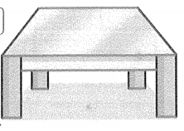
- These are new ________________. | 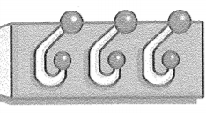
- This _____ a new ________________.

- __________are new_________________. | 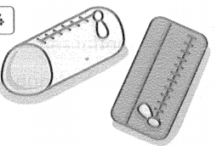
- __________________________________. | 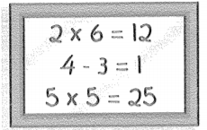
- Answer the questions. ( trả lời các câu hỏi)
- How’s the weather? | ___________________________________
- How old are you? | ___________________________________
- How many students are there in your class? | ___________________________________
- When do you have English? | ___________________________________
- What do you have on Monday? | ___________________________________
- Do you have music on Tuesday? | ___________________________________
- Does she have math on Tuesday? | ___________________________________
- What do you like? | ___________________________________
- Write the long and short forms.
long form | short form
- I do not have lots of book. | I don’t have lots of book.
- She is not a new student.
 | Nam doesn’t like robots.
- They are not happy.
 | I don’t want a long ruler.
- He does not like cats.
The end.

