Name:…………………………………………………
Class:……………..
REVIEW UNIT 1
I. Write their names

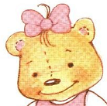
1…………………. 2…………….. 3……………………...
II. Complete the sentences
1.I’m………………………………………………
2. I’m………………………………………………
3. I’m…………………………………………….
III. Fill in the blank
1. he…lo 7. …iss …olly
2. h… 8….enny
3. I’…………. 9….ue
4. B…nny 10. H…llo
5. Su…
6. M…ss Dol…y

III. Matching
1. I’m Benny. A.
2. I’m Sue. B.
3. I’m Miss Dolly. C.

IV. Complete the dialogue
Sue: Hello,………………………. I’m………………………….
Benny: Hi,……………………….

Miss Dolly: Hi,……………………….
Benny: Hi,……………………….

Sue: ........................, teacher
Miss Dolly: Hi,……………………….

V. Write numbers
1………………
2……………….
3………………..
4………………….
5…………………
REVIEW UNIT 2
I. Matching
1. My………………… Benny. A.
2. …………..name’s Sue. B.
3. I’m ………………… Dolly. C.
II. Write
My name’s Sue | My name’s Benny | I’m Miss Dolly
1……………………………………………………………………
2……………………………………………………………………..
3…………………………………………………………………….
III. Fill in the blank
1……………………………..morning, teacher.
2. ……………………..name’s Hoa.
3. I’…………………….Miss Dolly.
4. ………………………bye, teacher.
5. I’m……………………….boy.

IV. Complete the dialogue
Sue:Good………………………………, Benny
Benny: …………………………………………, Sue

Miss Dolly:Good…………………………………., Benny.
Benny:………………………………………………, teacher.

Sue: Good morning,…………………………………
Miss Dolly:………………………………………., Sue.

V. Match
1. hello A. xin chào

2. good morning B. Tôi tên là Lan.

3. Hi C. Chào buổi sáng

4. name D. tên

5. Benny E. Xin chào

6. My name’s Lan F. Benny (tên nhân vật)

REVIEW UNIT 3
I. Look and write

1. I’m a……………………. 2……………………….. 3……………………
II. fill in the blank
1.g…rl 9. …oy
2. bo…. 10. Te…cher
3….eacher 11. ..ank yo…
4. H…w 12. …ine
5. ar… 13. ar…
6. y…u 14. gir…
7. fi…e 15. hell…
8. than… y…u 16. go…d …orning
III. Complete the sentences
1. How…………………..you ?
2………………………., thank you.
3.I’…………………….a boy.
4……………..’m a girl.
5………………………a teacher.
6. ……………………morning.
7. My……………………………Hoa.
8. He……………………………, teacher.

IV. Look and write
1. I’m ……………….. 2………………….. 3………………………
V. Translate into English
1. Tôi là cô giáo:………………………………………………………………………..

2. Tôi là con trai:………………………………………………………………………..

3. Tôi là con gái:………………………………………………………………………..
VI. complete the dialogue
Miss Dolly :How are…………………………… ?
Sue : Fine,……………………………..you.

Benny: Good………………………..…………….,Sue.
Sue: ………………………………………………., Benny. How ………………you?
Benny: …………………….., thank you.

Miss Dolly:Good morning,…………………………..
Sue: Good morning,…………………………….. How are you?
Miss Dolly:……………………,thank……………………………

REVIEW UNIT 4
I. Look and write
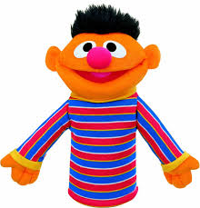
1……………………….. 2………………………… 3……………………
II. Fill in the blank
1. than… y…u 11….ook
2. boo… 12.pupp…t
3. …uppet 13. …elcome
4. yo… 14c…ayon
5. c…ayon 15. gi…l
6. we…come 16. bo…
7. You’r… 17. teache…
8. b…y 18. Y…u’re
9. t…acher 19. Than… y…u
10. …irl 20. Gre…n
III. Fill in the blank
1. Thank………………………………
2. You’…………………………..welcome.
3. Good………………………………………
4. I’m a t…………………………………..
5. My………………………………Benny.
6. I’m……………………………..girl.
7. ………………………..a boy.
8. ……………………….you
9………………………………welcome.
10. Good……………………………….., teacher.
IV. Unscramble and write
1.conray…………………………… 6. oyb……………………………….
2. putppe………………………… 7. olleh…………………………..
3. oobk…………………….. 8. achteer…………………………
4. ennyb…………………….. 9. inpk…………………………….
5. ilgr………………………. 10. Imss llydo……………………..
V.Complete the dialogue
Sue: ………………….. book.
Benny:……………………………..you.
Miss Dolly: You’………………… welcome

Hoa:………………………….crayon
Lan: thank……………………………….
Teacher: You’re………………………………………….

Hai: ………………………..puppet.
Nam: thank………………………………………..
Miss Huong: ………………………………………………..

REVIEW UNIT 5
I. Look and write
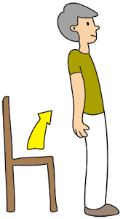
1………………………………….. 2…………………………..
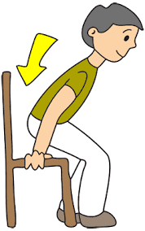
3……………………………………. 4…………………………….
II. Write
1. ngồi xuống:…………………………………………..
2. Quay vòng tròn:……………………………………..
3. đứng lên:……………………………………………
4. Nhảy:…………………………………………………
III. Fill in the blank
1. ou…h 8. teac…er
2. j…mp 9. …own
3. do…n 10. …orry
4. tu…n aroun… 11. …uppet
5. I’m so…ry 12. Cray…n
6. pu…pet 13. …ump
7. ….rayon 14. Ouc….
IV. Match
1. jump

2. up

3. turn around

4. down

V. Unscramble and write
1. uoch…………………………………………
2. umpj……………………………………..
3. tunr aruodn………………………………….
4. pu……………………………………….
5. kboo……………………………………
6. glir…………………………………….
7. byo…………………………………..
8. ppupet………………………………..

REVIEW UNIT 6: NUMBERS
I. Write numbers
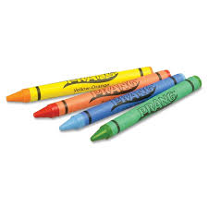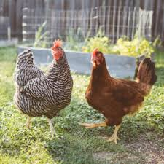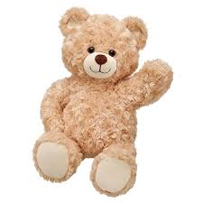
…………………….. ……………………. ………………………
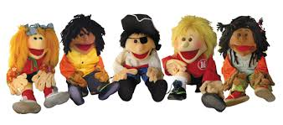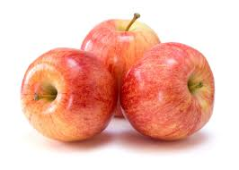
…………………………….. …………………………………..
II. Calculate
3+1=…………………………………………………………………………………
2+3=…………………………………………………………………………………
8-7=…………………………………………………………………………………
5-3=…………………………………………………………………………………
1+2=…………………………………………………………………………………
III. Fill in the blank
1. on…
2. f…ve
3. th…ee
4. tw…
5. …our
6. cou…t
7….eacher
IV. Match
Four * *

One * *

Three * *

Five * *

Two * *
V. Complete the sentences
1. Good…………………………………., Benny.
2……………………..name’s Sue.
3. How……………………….you?
4. Thank…………………………….
5. I…………………………..pink.
6.Thank………………………..
REVIEW UNIT 7: SNACKTIME
I. Look and write
1.  ………………………………………………………………………………….
2.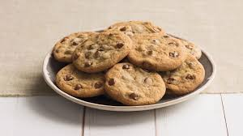……………………………………………………………………3.…………………………………………………………………...
4. 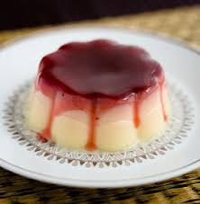…………………………………………………………………………
II. Fill in the blank
1. s…ack ti…e
2. pud…ing
3. co…kies
4. her… y…u ar…
5. a…ples
6. …uice
7. p….ease
8. I’…… sorr….
9. good…………………………
10. fine,…………………………you.
III. Complete the sentences
1. snack………………………………….
2. Cookies,…………………………………
3. Here…………………………..are.
4. Pudding,…………………………..
5………………………….you are.
6. apples,…………………………….
7.Here you……………………………….
8. Juice,………………………………….
9. Here you………………………………..
10. …………………………you.
11. ……………………………….a boy.
12…………………………………a girl.
13. ……………………………….a teacher.
14………………………………..bye
IV. Complete the dialogue
Sue: ………………………….time
Benny: cookies,……………………………..
Miss Dolly: Here…………………………….are

Sue: Snack time
Benny: a………………………………, please.
Miss Dolly: Here you……………………………………….

Hoa: Snack………………………………….
Mai: Juice,…………………………………………
Teacher:…………………………………………………………
REVIEW UNIT 8: COLORS
I. Fill in the blank
1. gree…
2.y…llow
3. pur…le
4. pi…k
5. bl…e
6. r…d
7. gra…
II. Complete the sentences
1. I…………………………..green.
2. I ………………………….blue.
3. I ………………………………………….pink.
4.Me,…………………….
III. Color
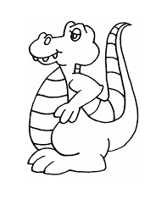
YELLOW RED
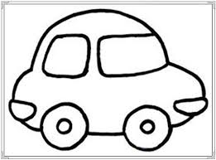
BLUE PURPLE
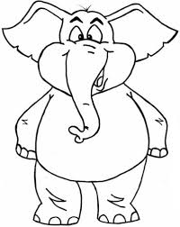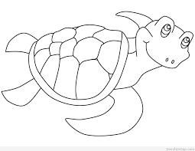
GREEN PINK
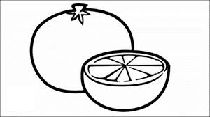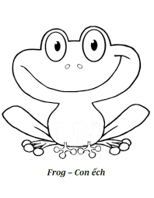
RED GREEN
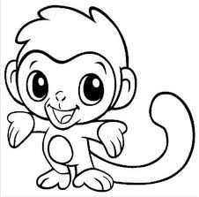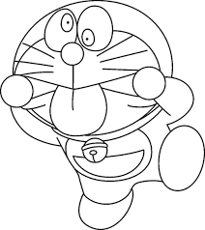
PINK BLUE
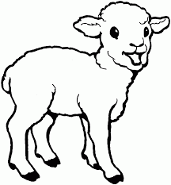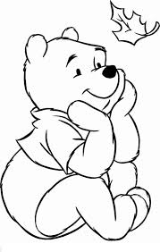
YELLOW RED

REVIEW UNIT 9: READY TO GO
I. Look and match
1. stand up A. 
2. line up B. 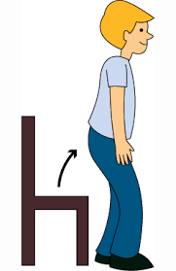
3. march C. 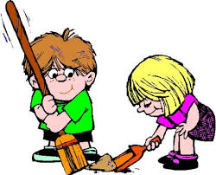
4. Clean up D. 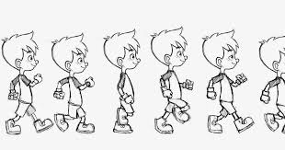
II. Look and write
……………………………………………………………………
………………………………………………………….
……………………………………………………………….
……………………………………………………………………………….

III.Fill in the blank
1. go…d by…..
2. b…e
3. se… y…u tomorr…w
4. stan… up
5. lin…. up
6. cl…an up
7. mar…h
8. see yo… to…orrow
9. l…ne up
10. m….rch
IV. Unscramble and write
1. ilne pu………………………………………..
2. mchar………………………………………..
3. clane up…………………………………………
4. tasnd up……………………………………..
5. oockies……………………………………….
6. dpuding…………………………………….
7. alespp…………………………………….
8. jiuce……………………………………
9. teahrec……………………………………..
10. bey gdoo…………………………………..

REVIEW UNIT 10: ON THE BUS
I. Look and macth
1. car A. 
2. bus B. 
3. truck C. 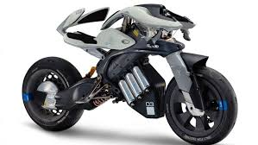
4. motorcycle D. 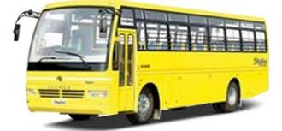
II. look and write
……………………………………………………………….
……………………………………………………………..
……………………………………………………………..
………………………………………………………………….

III. Fill in the blank
1. Loo….
2. ca….
3. It’…..a bus.
4. …………………….a motorcycle.
5. Sit……………………………………..
6. t…uck
7. It’s a b…………………………………….
8. It’s a c…………………………………………
9. It’s a tr…………………………………………..
10. It’s a mo………………………………………
IV. Color: 1:
1. pink 2. Purple 3. Green 4. Red 5. Gray 6. Blue 7. Yellow

2
3
5
6
1

4

7

Teacher: Doan Thi Duyen Hai

School:………………………………………………………..
Class:…………………………………
Name:…………………………………..
Mini test
I. Write the words
1………………………… 2…………………………3………………………

4………………… 5………………………. 6………………….
7………………………… 8……………………………. 9……………….

10…………………. 11…………………… 12….………………………
13…………………………………………..

II. Complete then sentences
1. ………………………………..morning, Sue.
2. I’………………………..a boy.
3. He…………………………, teacher.
4. Thank………………………..
5. How……………………..you?
6…………………………….., thank you.
7. I’………………………sorry.
8. I’m ………………………….teacher.
9. My……………………………………Trang.
10. Turn………………………………….
III. Fill in the blank
1. boo…... 6. Than….
2. …..uppet 7. Ou…h
3. u… 8. J….mp
4. d…..wn 9. Nam….
5. b….y 10. ….rayon

School:……………………………………………………….
Name:…………………………….
Class:………………..
Time: 30’
TEST 1
I. Write their names
1…………………….. 2…………………………. 3………………
II. Correct
1. gooy morning …………………………….…………………………..
2. I’m teacher …………………………………………………………….
3. How ar you? ………………………………………….……………………….
4. Five, thank you. ……………………………………………………………..
5. Helo …………………………………………………………………...
6. I a boy …………………………………………………………………..
7. a bool ………………………………………………………………
8. My name Sue………………………………………………………………….
9. rayon ……………………………………………………………………
10. pupet…………………………………………………………………………

III. Match

1. a puppet A. 

2. a crayon B. 
3. a book C. 
IV. complete the dialogue
Sue: ………………….book
Benny: thank………………………….
Miss Dolly: You’………………. welcome.
V. Complete the sentences
1. Good…………………………
2. I’m………………………..girl.
3. How………………………you?
4. ……………………….you.
5. My………………………………………Lan.
GOOD LUCK TO YOU!!!!

